DIGI NURTURE 4.0
WEEK 5
1.ReactJS.HOS
Terminal output
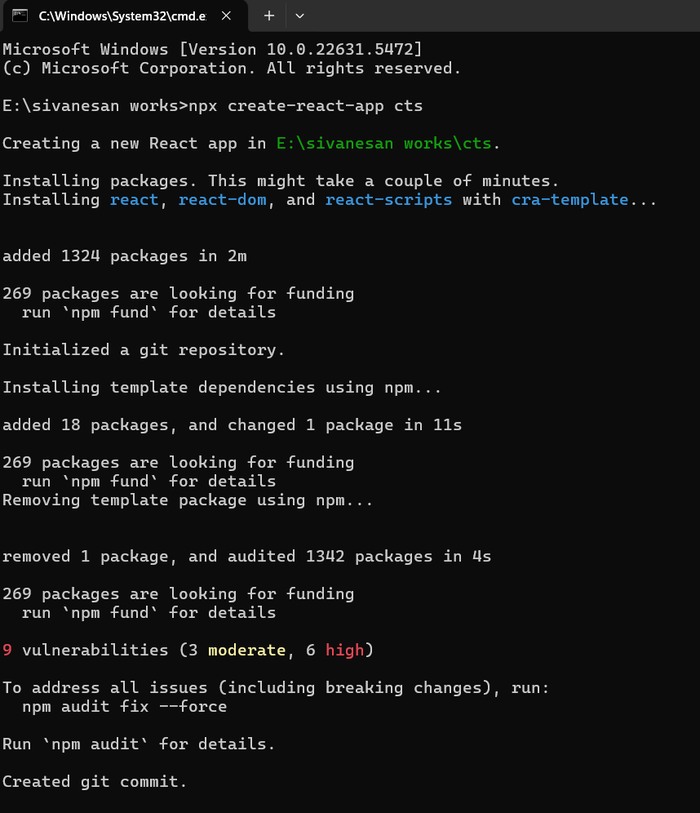
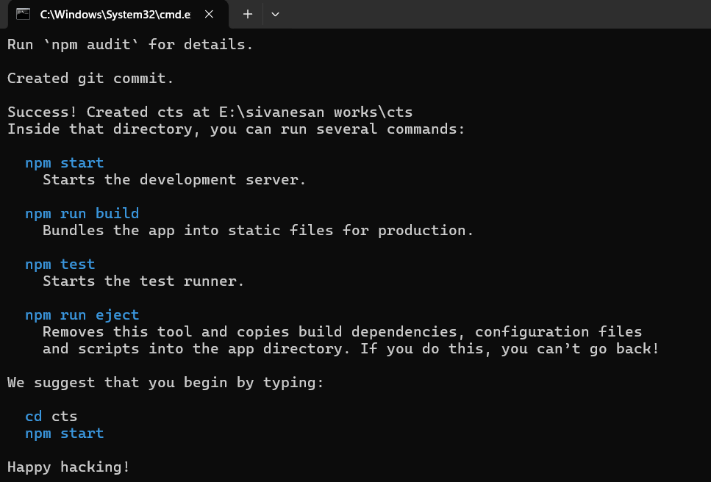

siva.jsx
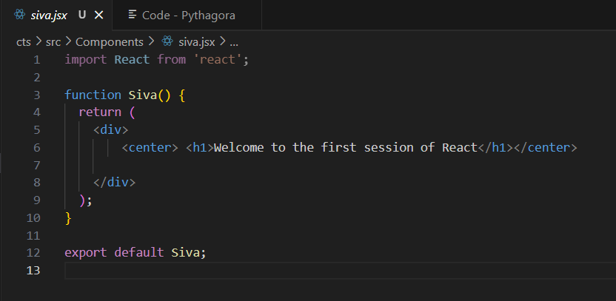

App.js
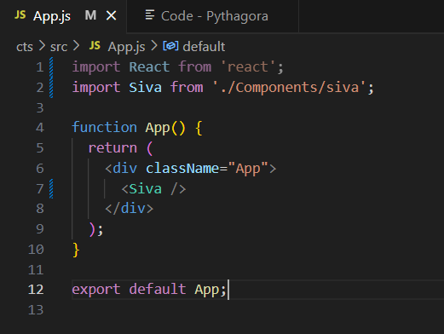

localhost.3000
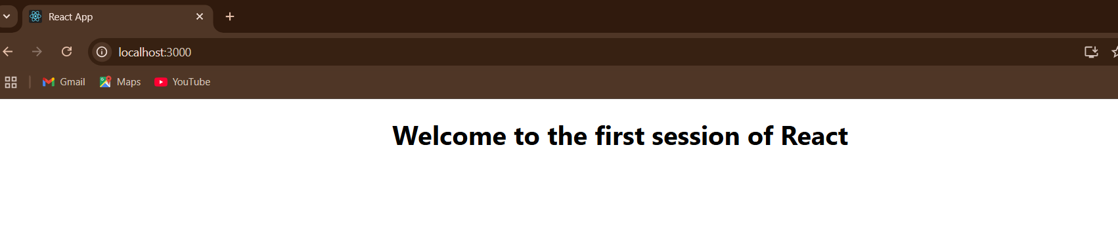

2.ReactJS.HOS
Terminal output
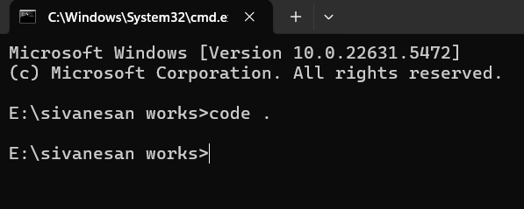
App.js
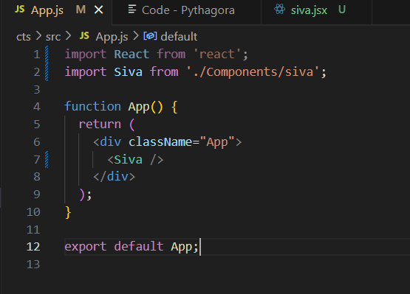

siva.jsx
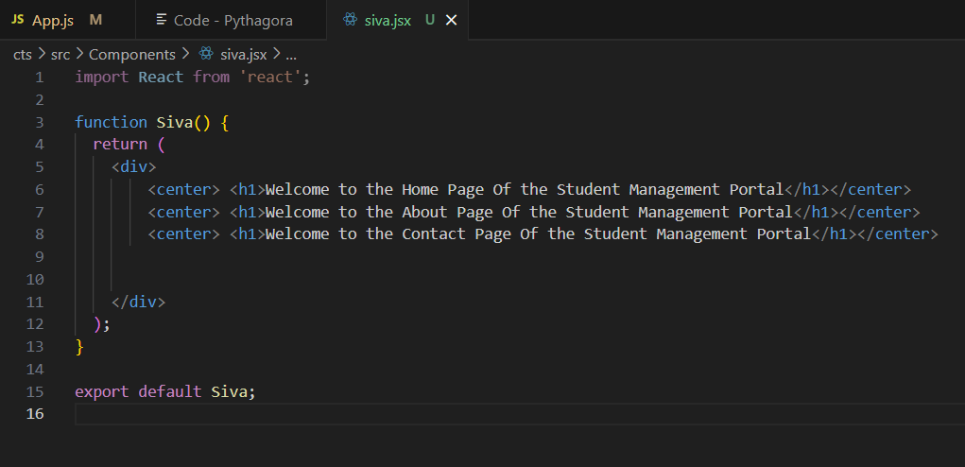

Terminal output
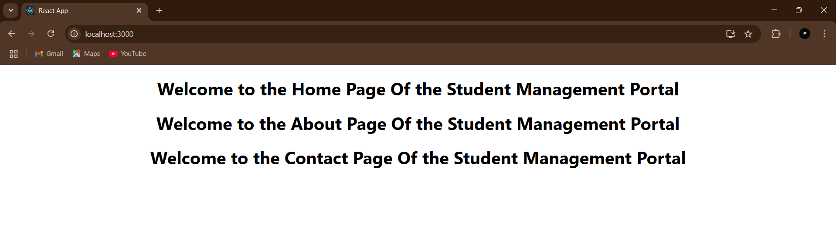

3.ReactJS.HOS
Terminal output
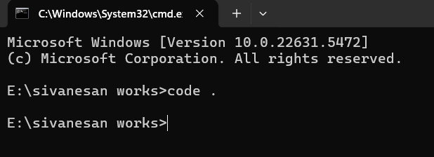

App.js
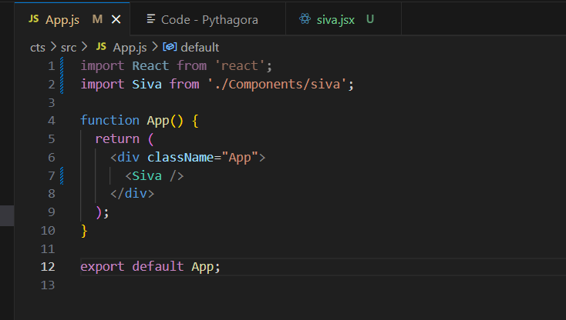

siva.jsx
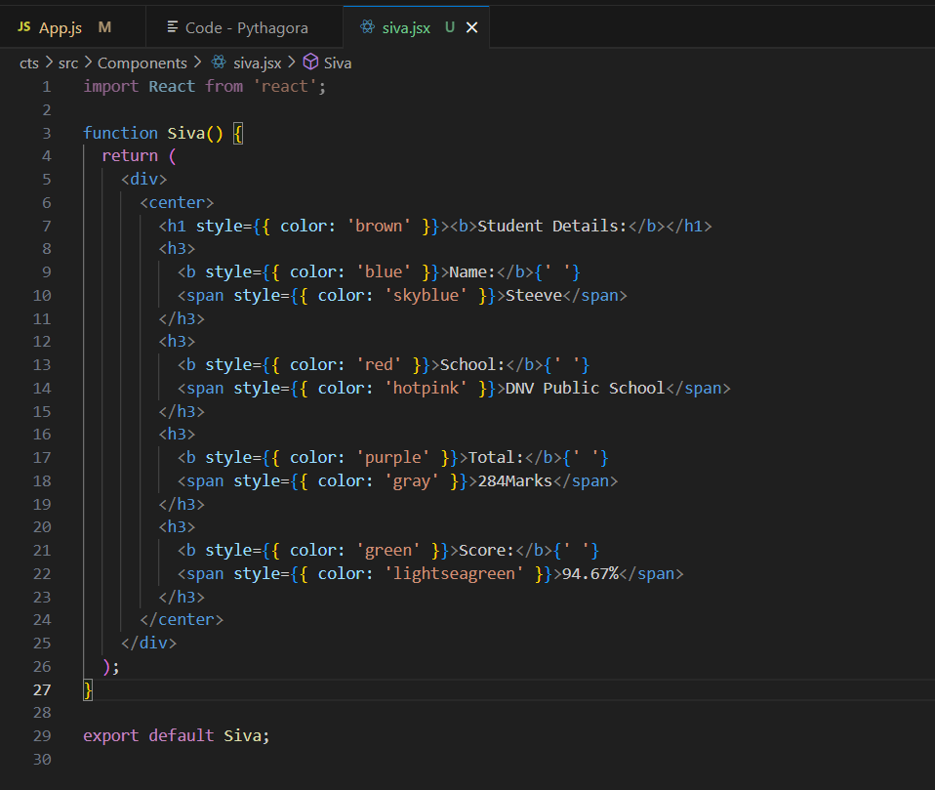

localhost:3000
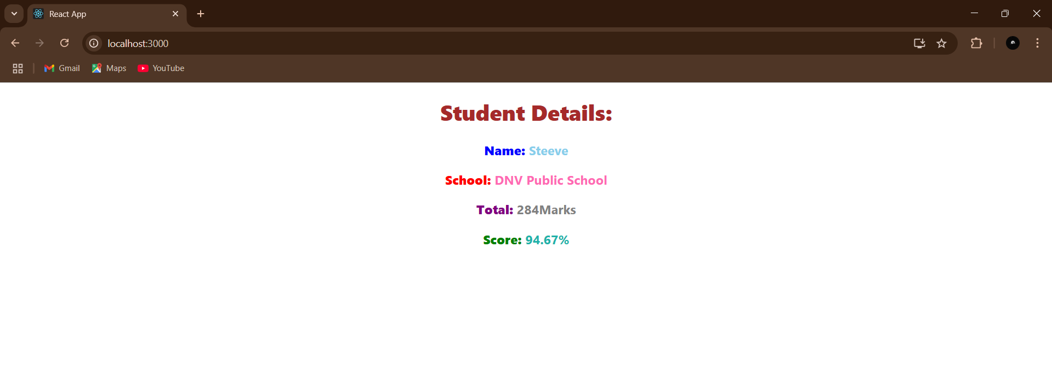

4.ReactJS-HOL
Program:
- open vs code terminal or cmd and create blogapp in react using the following command npx create-react-app blogapp
- open the folder in vscode and create a post.js,posts.js in src folder .

post.js:
import React from 'react';

class Post extends React.Component {
render() {
return (
<div style={{ margin: '10px', padding: '15px', border: '1px solid #ccc' }}>
<h3>{this.props.title}</h3>
<p>{this.props.body}</p>
</div>
);
}
}
export default Post;
posts.js:
import React from 'react';
import Post from './Post';

class Posts extends React.Component {
constructor(props) {
super(props);
this.state = {
posts: [],
hasError: false
};
}

loadPosts = () => {
fetch('https://jsonplaceholder.typicode.com/posts')
.then(response => response.json())
.then(data => this.setState({ posts: data.slice(0, 10) })) // limit to 10 posts
.catch(error => {
console.error("Fetch error:", error);
this.setState({ hasError: true });
});
};

componentDidMount() {
this.loadPosts();
}

componentDidCatch(error, info) {
alert("An error occurred while loading posts.");
console.error(error, info);
this.setState({ hasError: true });
}

render() {
if (this.state.hasError) {
return <h2>Something went wrong.</h2>;
}

return (
<div>
<h2>Blog Posts</h2>
{this.state.posts.map(post => (
<Post key={post.id} title={post.title} body={post.body} />
))}
</div>
);
}
}

export default Posts;

- modify the src/App.js

App.js:
import React from 'react';
import './App.css';
import Posts from './Posts';
function App() {
return (
<div className="App">
<Posts />
</div>
);
}

export default App;

- run the npm start command in the terminal
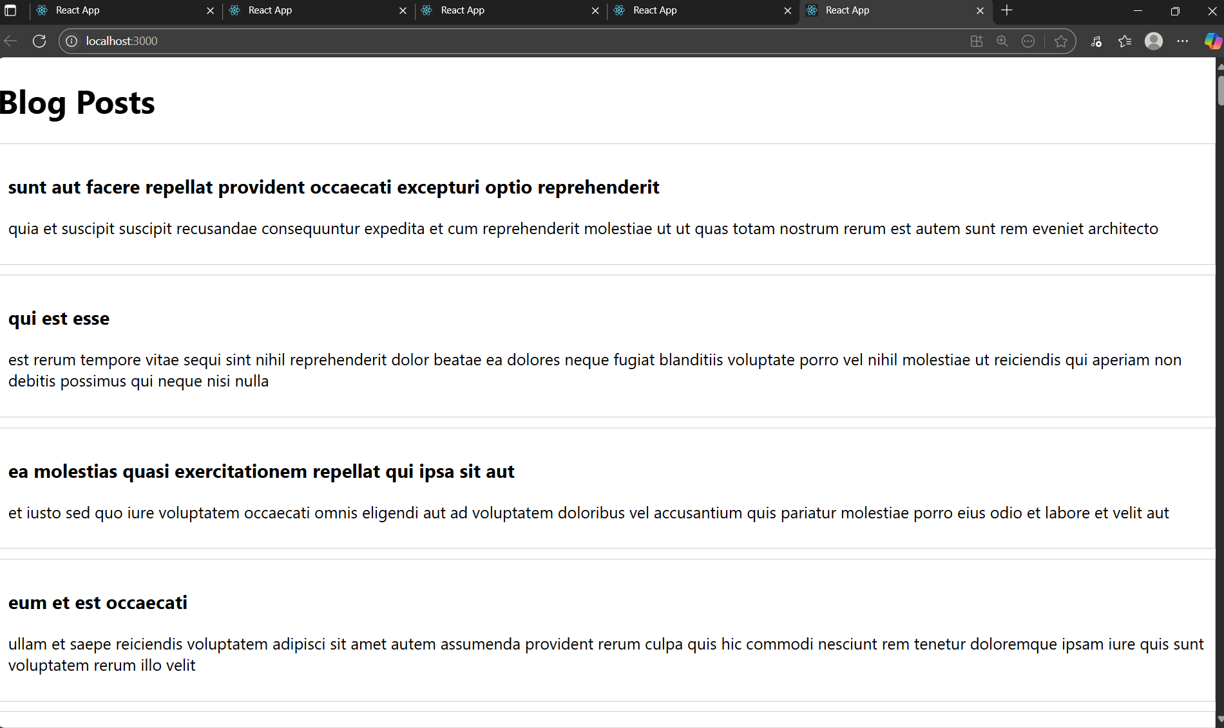
OUTPUT:

5.ReactJS-HOL

Program:
- Create a react app named cohortdashboard using the following command
npx create-react-app cohortdashboard
- Create Cohortdetails.js and CohortDetails.module.css in the src folder.

CohortDetails.js:

import React from 'react';
import styles from './CohortDetails.module.css';

function CohortDetails({ name, status, startDate, endDate }) {
const headingStyle = {
color: status === 'ongoing' ? 'green' : 'blue',
};

return (
<div className={styles.box}>
<h3 style={headingStyle}>{name}</h3>
<dl>
<dt>Status:</dt>
<dd>{status}</dd>
<dt>Start Date:</dt>
<dd>{startDate}</dd>
<dt>End Date:</dt>
<dd>{endDate}</dd>
</dl>
</div>
);
}
export default CohortDetails;

CohortDetails.module.css:
.box {
width: 300px;
display: inline-block;
margin: 10px;
padding: 10px 20px;
border: 1px solid black;
border-radius: 10px;
}

dt {
font-weight: 500;
}

- Modify the App.js in the src folder.

App.js:

import React from 'react';
import './App.css';
import CohortDetails from './CohortDetails';

function App() {
const cohortList = [
{
name: 'Java Full Stack',
status: 'ongoing',
startDate: '2024-07-01',
endDate: '2024-12-01'
},
{
name: 'React Bootcamp',
status: 'completed',
startDate: '2024-01-15',
endDate: '2024-06-15'
}
];

return (
<div className="App">
{cohortList.map((cohort, index) => (
<CohortDetails
key={index}
name={cohort.name}
status={cohort.status}
startDate={cohort.startDate}
endDate={cohort.endDate}
/>
))}
</div>
);
}

export default App;

- Run the npm start command in terminal
Output:

